From: https://medium.com/microbial-instincts/biodistribution-and-spike-protein-safety-of-mrna-vaccines-an-update-788fe58e39b9
Biodistribution and Spike Protein Safety of mRNA Vaccines: An Update
It’s easy to misinterpret science, and it takes more effort to understand the true narrative.
Author: Shin Jie Yong
Following
Jul 7, 2021 · 11 min read
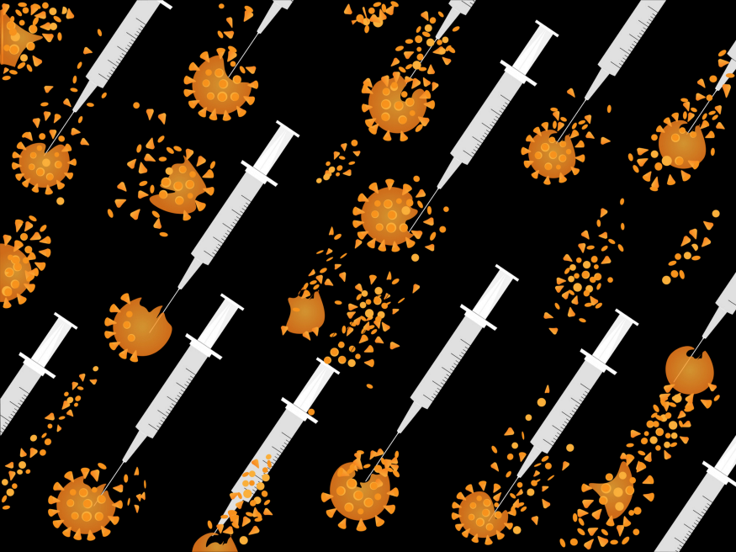
Source: iStock
In the past few months, there has been a push for the idea that the spike proteins related to mRNA vaccines are toxic to our bodies. The vaccine can cause spike protein deposition in the ovaries, for example, but is this really true? I wish there’s a yes or no answer to this question, but the science behind it isn't so straightforward. Rest assured, however, that the mRNA vaccines aren't toxic to the ovaries or any other tissues.
This article will explain why, as objectively as possible, and also serve as an update to a related article about spike protein safety I wrote back in December 2020 and another one about mRNA vaccine biodistribution I wrote four months ago.

How Covid-19 vaccines work in brief
Nearly all the vaccines against Covid-19 use the SARS-CoV-2’s spike protein to induce immunity in some way or another. (SARS-CoV-2 is the coronavirus that causes Covid-19.)
- The mRNA vaccine, for example, uses lipid nanoparticles (LNPs) to deliver mRNA into cells. This mRNA instructs the [your] cell to make the spike proteins of SARS-CoV-2 that provoke immune reactions.
- The DNA vaccine acts similarly, using adenovirus to carry spike protein-encoding DNA into cells. The protein subunit vaccine, on the other hand, directly administers purified spike proteins into the body.
- In contrast, inactivated vaccine uses dead virions with intake spike proteins to induce immunity.
SARS-CoV-2 has spike proteins on its surface that latch on the ACE2 receptor on human cells. The spike protein-ACE2 binding allows SARS-CoV-2 to infect cells to replicate itself. Thus, vaccines aim to train our immune system to neutralize the spike proteins, preventing SARS-CoV-2 from infecting cells.

The biodistribution and toxicity concern
In an interview on 28 May 2021 that went viral, Byram W. Bridle, Ph.D., an associate professor specializing in virology and immunology, claimed that he and collaborators had obtained a ‘biodistribution study’ of the mRNA vaccine from the Japanese regulatory agency.
Prof. Bridle then said spike protein is a known toxin, which will harm the tissue it accumulates in. He speculates that this could be the culprit behind the blood clots (in the brain and other organs) and heart inflammation cases that are associated with Covid-19 vaccines.
Basically, Prof. Bridle said:
It’s the first time ever scientists have been privy to seeing where these [mRNA] vaccines go after vaccination. Is it a safe assumption that it stays in the shoulder muscle? The short answer is: absolutely not. It’s very disconcerting. The spike protein gets into the blood, circulates through the blood in individuals over several days post-vaccination…It accumulates in a number of tissues, such as the spleen, the bone marrow, the liver, the adrenal glands [and particularly] the ovaries…The conclusion is we made a big mistake. We didn’t realize it until now. We thought the spike protein was a great target antigen. We never knew the spike protein itself was a toxin and was a pathogenic protein. So by vaccinating people, we are inadvertently inoculating them with a toxin.”
J. Patrick Whelan, MD, Ph.D., a pediatric rheumatologist, shared the same concern, warning the Food and Drug Administration (FDA) via a public submission in December 2020 that:
I am concerned about the possibility that the new [mRNA] vaccines aimed at creating immunity against the SARS-CoV-2 spike protein have the potential to cause microvascular [small blood vessels] injury to the brain, heart, liver, and kidneys in a way that does not currently appear to be assessed in safety trials of these potential drugs.
In June 2021, Robert W. Malone, MD, MS, one of the pioneers of mRNA and DNA vaccine technology, also said that spike proteins are ‘cytotoxic’ (toxic to living cells) in a podcast and tweet:
The SARS-CoV-2 spike protein is cytotoxic. That is a fact. Who says so? Multiple peer reviewed references. The Salk Institue. It is the responsibility of the vaccine developers to demonstrate that their expressed version is not toxic. Show us.
Therefore, the overall cause for worry is that spike protein-based vaccines could distribute cytotoxic spike proteins throughout the body, beyond the injection site, and harm the host.

Addressing the biodistribution concern
Prof. Bridle mentioned that the vaccine-derived spike proteins could enter the bloodstream and settle on various tissues, particularly the ovaries, based on the Japanese biodistribution study of the Pfizer mRNA vaccine.
Japan insisted on completing its own preclinical and clinical trials before authorizing the vaccine for use for Japanese people. Although this action has delayed vaccine roll-out, we also get more data on the Pfizer mRNA vaccine in addition to other governmental reports.
In this Japanese study, a substantial amount of the Pfizer mRNA vaccine settled in the injection site, liver, spleen, adrenal glands, and ovaries of rats at 48 hours following intramuscular injection (see yellow highlights below). But these numbers alone can be misleading.
As Abraham Al-Ahmad, Ph.D., an associate professor of pharmacology, who specializes in drug biodistribution in the brain, expertly explained:
That person is providing us with amount of the radiolabeled tracer detected in the tissue (e.g. ug/g tissue), with the approximation of total lipids amount in tissue. This assumes that the nanoparticles made it through the tissue complete, but we cannot exclude that we are maybe measuring only the 08-A01-C0 compound accumulation. In practice, we usually focus our attention on the percentage of injected dose (% ID) when it comes to appreciate the distribution and the delivery of a drug into an organ/tissue.
Basically, the numbers highlighted in yellow refer to total lipid content, including both the mRNA vaccine’s LNPs (lipid nanoparticles) and lipid tracer (i.e., 08-A01-C0 compound). Thus, the more appropriate numbers to look at should be the “% of administered dose” highlighted in cyan.
Now, the numbers are no longer nerve-racking: Only <1% of the injected mRNA vaccine got into the ovaries, adrenal glands, heart, brain, and other tissues at 48-hour. Most of the vaccine remained in the injection site and went into the liver, “suggesting these LNPs may be eliminated mostly via hepatic [liver] clearance route,” Prof. Al-Ahmad wrote.

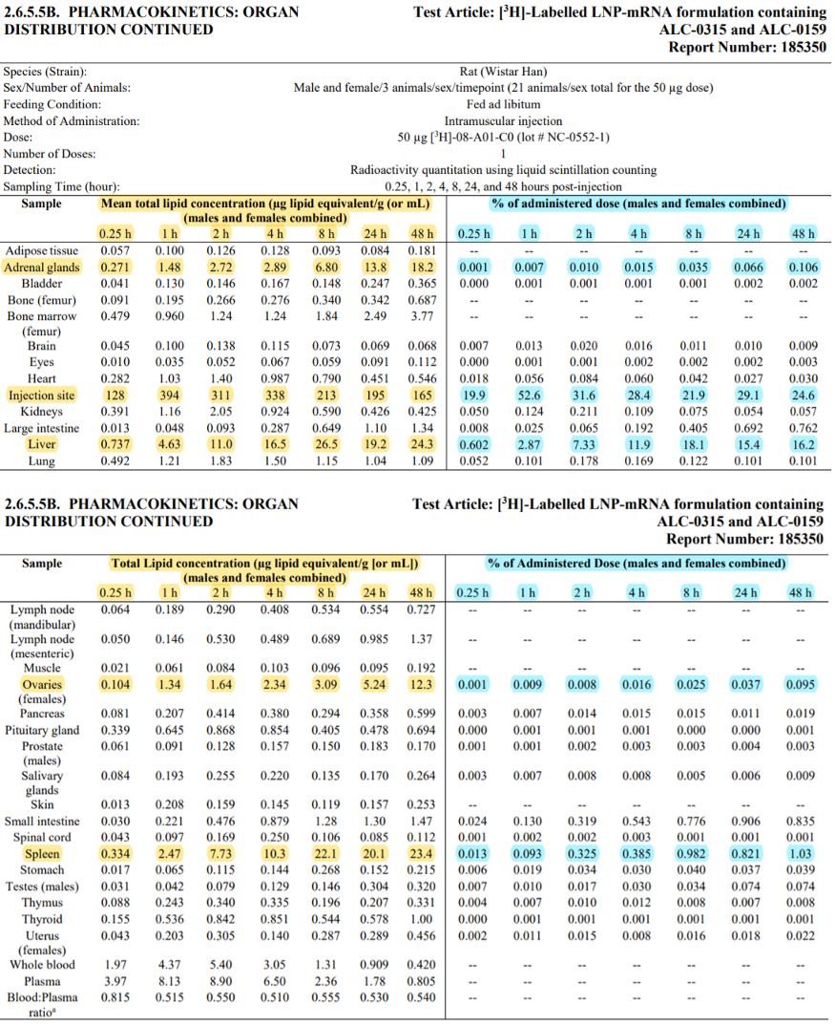
Source: Japanese government report. Page 6–7 of ‘Pharmacokinetics Overview’ section (or pdf page 16–17).
Even the dose the Japanese study used is very high when controlled for weight; that is, 18–35-times higher than what is injected into humans. As David H. Gorski, MD, Ph.D., a professor of surgery and blogger, explained:
The human vaccine contains…~0.46 mg lipids or 460 μg. Let’s just round it up to 500 μg (0.5 mg). That’s approximately 10x the dose given to the rats. However, for the typical ’70 kg’ male, 0.5 mg represents a per-weight dose of 0.0071 mg/kg, or 7.1 μg/kg. Let’s compare to the rats, which generally weigh around 200 g (0.2 kg)…That would translate to a per-weight dose of ~250 μg/kg. Even if you used much older rats, who can weigh as much as twice as much, that would still translate to a dose of 125 μg/kg. So we’re looking at a lipid nanoparticle [dose] of ~18–35 times higher (as a rough estimate) than the typical adult human dose.
The Japanese biodistribution study results are consistent with Pfizer’s that was submitted to the European Medicines Agency (EMA) in February 2021. Pfizer also found that the LNP-encapsulated mRNA vaccine was mainly metabolized in the liver and did not enter other tissues easily. They also noted no effects on fertility or ovarian functions.
As the EMA report stated:

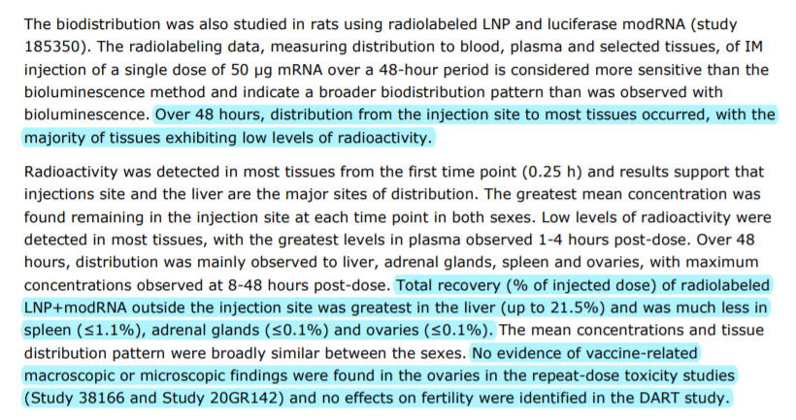
Source: EMA assessment report on the Pfizer mRNA vaccine; page 47 out of 140. Note: DART stands for Development and Reproductive Toxicology (in rats).
For the Moderna mRNA vaccine, the EMA assessment report has previously released its biodistribution data that also finds no cause for concern. Although the Moderna LNP-encapsulated mRNA vaccine entered various tissues at low amounts, they are mostly gone by the third day.
As stated in the EMA report :

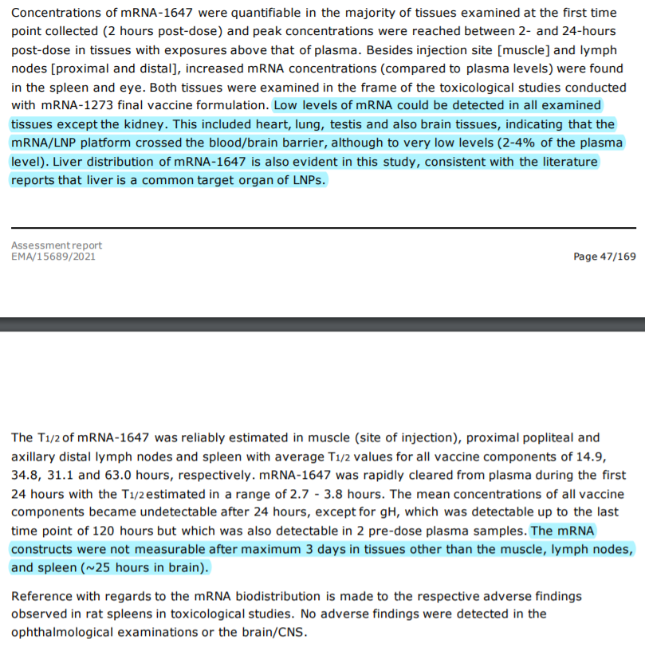
Source: EMA assessment report on the Moderna mRNA vaccine; page 47–48 out of 169.
Overall, these biodistribution studies show that the Pfizer and Moderna mRNA vaccines do not enter other tissues or organs easily.
Even if the mRNA vaccines did enter the ovaries in tiny amounts, there’s no evidence that ovarian cells can translate the mRNA into spike proteins. Even if ovarian cells somehow managed to manufacture some spike proteins, there’s no evidence that this can harm the ovaries. Maybe the spike proteins expressed on ovarian cells degrade within hours or days and disappear in a few days. Animal studies have shown that cells that take up the mRNA vaccine only express the mRNA-encoded proteins on its surface for about 48 hours, which then quickly decline to zero in a few days.
Thus, multiple stringent biochemical conditions and steps must be met to even allow for the tiniest possibility of mRNA vaccine harming the ovaries or other tissues. (I discussed this in-depth for the brain here.)

Addressing the biodistribution concern part II
But critics will question three things: (1) such studies are done in rats; (2) such studies used luciferase-encoding mRNA rather than the spike protein-encoding mRNA; and (3) such studies do not measure the spike proteins. All these critics [criticisms] are, honestly, valid limitations of the biodistribution studies.
- For (1): While rats are mammals like humans, the more convincing animal model is non-human primates like monkeys.
- For (2): Luciferase is a type of protein that lights up under imaging scans, enabling researchers to see where the LNPs had carried the mRNA (that encodes luciferase) into. So, luciferase-based studies only show biodistribution of LNPs, not spike proteins.
- For (3): Since luciferase-based studies don’t inform spike protein biodistribution, we still don’t know where the manufactured spike proteins go after vaccination. For instance: when the mRNA vaccine instructs muscle cells (at the injection site) to make spike proteins, where will these spike proteins go?
As points (1) and (2) are not really major issues, point (3) needs to be taken more seriously. Thankfully, the mRNA vaccines are designed in such a way that the vaccine-derived spike proteins are anchored onto the cell surface. This means that the manufactured spike proteins (at the instruction of the mRNA vaccine) get stuck on the cell. Hence, spike proteins made by muscle cells at the injection site will stay at the injection site.
“A mutation where amino acids 986 and 987 are replaced with prolines (S-2P), stabilizing the transmembrane-anchored S glycoprotein in the prefusion conformation but still allowing for cleavage of the S1 and S2 subunits, is the approach used in the licensed vaccines mRNA-1273 [Moderna] and BNT162b2 [Pfizer],” immunologists wrote. The keyword is transmembrane-anchored, where the vaccine-derived S glycoprotein (or spike protein) is anchored on the cell membrane.
But some will question that maybe some of the spike proteins get unstuck from the cells. As a result, spike proteins made at the injection site might go and wreak havoc elsewhere. To this end, during the interview, Prof. Bridle cited a study from Harvard Medical School that detected spike proteins in the bloodstream of 11 out of 13 recipients of the Moderna mRNA vaccine on day-1.
Besides the small sample size, this study actually detected very tiny amounts of spike proteins with an ultrasensitive technology that’s not often used. Plus, the Harvard study found that spike protein amount in the blood declined after day-1 and was no longer detectable on day-14.
However, this study has been used to push the notion that authorities and experts lied about the vaccine-derived spike proteins being anchored on the cell surface. But all assays (or tools) have a limit of detection. It’s just that the Harvard study used a special assay called Simoa that reached the picograms (a trillionth of a gram) level of detection.
Deplatform Disease, a science blog many experts have cited, calculated that the detected levels of spike proteins in the Harvard study were 100,000-times lower than the amount that might cause harm.
While the root cause is unclear, the detected spike proteins in the blood of vaccinated persons in this study might be due to (1) too many anchored spike proteins on the cell surface that a few got released or (2) usual day-to-day cell death that release some of the anchored spike proteins.

Addressing the spike protein toxicity concern
…100,000-times lower than the amount that might cause harm? Yes, many studies using cultured cells and animals have found that the spike protein of SARS-CoV-2 alone — without its genome — is sufficient to harm blood vessels at a certain concentration. (Such concentrations are 100,000-times higher than the amount detected in the Harvard study.)
But all of such studies have one thing in common: they use the spike protein of SARS-CoV-2, not vaccine-derived ones. The one Dr. Malone particularly pushed is from Salk Institute, where researchers injected SARS-CoV-2 spike proteins into hamsters, which injured the lungs and blood vessels due to angiotensin-converting enzyme 2 (ACE2) dysregulation.
This ACE2 dysregulation finding is very crucial. ACE2 is the receptor that the spike protein of SARS-CoV-2 binds to in order to infect human cells. Too much binding and activation of ACE2 throws off the balance in the renin-angiotensin system (RAS). RAS regulates blood pressure and the vascular system, so its dysregulation will upset blood vessel functions.
But Carolyn Machamer, Ph.D., a professor of cell biology, explained:
There are changes that were made on purpose that would prevent the spike protein from being able to undergo binding to the [ACE2] receptor and fusion. And so, all this business about toxicity that has been shown for the real spike protein, the one that doesn’t have that block, is totally irrelevant for the vaccine.
Deplatform Disease further added:
…the spike protein in the Pfizer and Moderna vaccines is not quite the same as the wild-type spike protein found on the virus. This protein has been prefusion stabilized which means it lacks the ability to change conformation into its postfusion state (via a double proline substitution). This change is thought to significantly enhance the ability of the spike protein to elicit neutralizing antibodies from the immune system, but it also has another functional consequence: the spike protein has drastically less ability to cause syncytium formation…[that may] play a direct role in the disease process of COVID-19.
All these mean that the vaccine-derived spike proteins, at least for the mRNA ones, are modified so that they won’t bind to the ACE2 receptor. No binding means no activation, and there won’t be any problems in ACE2 or RAS in vaccinated persons.
A real SARS-CoV-2 infection, in contrast, floods the body with infectious virus particles, each with its own spike proteins that can bind to the ACE2 receptor and dysregulate RAS. One can only imagine the countless amount of spike proteins that Covid-19 deposits in its victims. No wonder blood vessel injury and blood clots are so common in Covid-19 patients.

Closing remarks
I must admit that this article can be heavy to read. Even I would not be able to comprehend all of this without the written explanations of other experts. No wonder it’s easy to misinterpret science, and it takes effort to understand the true narrative. And I hope this article provides a coherent read on this complicated matter.
In brief, while it’s true that the mRNA vaccine has a broad biodistribution in our body and that the spike proteins of SARS-CoV-2 are dangerous, the narrative doesn't end there. Minuscule amounts of mRNA vaccine entering other tissues or organs are only of minuscule significance, and membrane-anchored spike proteins from the vaccines are not dangerous. Although there will always be people and even experts who insist otherwise, let’s stay informed to differentiate between a good and bad scientific argument.

Microbial Instincts

Decoding the microbial angle to health and the microbial world.
Follow
623
3

Sign up for Microbial Instincts

